**Experimental evaluation of the use of vision and barbels as references for rheotaxis in green sturgeon**

Myfanwy E. Johnstona, John T. Kellyb, A. Peter Klimleya, Richard McElreathc, M. Emilia Lindvalla

a Department of Wildlife, Fish, and Conservation Biology

University of California

1 Shields Ave, Davis, CA 95616 USA

Email: apklimley@ucdavis.edu, melindvall@ucdavis.edu

b Department of Biology and Environmental Science

University of New Haven

300 Boston Post Rd.

West Haven, CT 06516 USA

Email: jkelly@newhaven.edu

c Max Planck Institute for Evolutionary Anthropology  
Department of Human Behavior, Ecology and Culture  
Deutscher Platz 6  
04103 Leipzig, Germany

Email: richard_mcelreath@eva.mpg.de

Corresponding Author: Myfanwy Johnston, merowlands@ucdavis.edu

ABSTRACT

Two experiments were conducted to investigate the role of visual stimuli and barbels in juvenile green sturgeon rheotaxis behavior. Fish displayed two distinct behavioral responses to either a photic or a mechanical stimulus, respectively. The green sturgeon spent a higher proportion of time positively oriented toward a flowing current (mechanical stimulus) than in the absence of flow but in the presence of a moving background (photic stimulus). Removal of barbels increased the average individual tendency to orient positively in the presence of flow. While visual cues almost certainly play a role in rheotaxis behavior at large, the photic stimulus used in these experiments was not as effective as the mechanical stimulus in eliciting positive rheotaxis behavior during the timed trials. The barbels of green sturgeon do not appear to influence their ability to display positive rheotaxis in the presence of flowing water.

*Keywords*:

Rheotaxis

Sturgeon

Sensory ecology

Bayesian

Beta distribution

**1. Introduction**

Rheotaxis, observed in many aquatic organisms, is the deliberate alteration of orientation of cells and/or organisms relative to the water current gradient (Arnold, 1974; Miki and Clapham, 2013). Fish may orient themselves upstream in order to either maintain a stationary position (termed “station holding”) or to actively travel upstream. Fish may also orient themselves downstream in order to maximize their rate of movement, or become passively entrained (‘carried’) in the direction of the current. These orientations are defined as positive, negative, and neutral rheotaxis, respectively (Arnold, 1974). Most fish exhibit innate rheotaxis, and the behavior plays an important role at every stage of life history (Arnold, 1974).

The relative importance of different sensory modalities to the rheotaxis response in fish is largely unknown. Fish rheotaxis may be directly stimulated by water flow over the lateral line, or indirectly by other types of stimuli, including visual and tactile cues (Montgomery et al., 1997). Deliberate rheotaxis (in the form of positive or negative orientation) requires a stationary external reference point (Montgomery et al., 1997), and vision may supply this reference point in many cases. However, in species that routinely inhabit or migrate through highly turbid environments, visual cues may not be relied upon as heavily as mechanosensory cues, if at all (Baker and Montgomery, 1999). For example, in *Astyanax fasciatus*, the superficial neuromasts of the lateral line along with olfactory cues provide reference points for rheotaxis (Baker and Montgomery, 1999). In species that utilize sensory barbels for foraging and sensing the substrate below them, including *Acipenser medirostris* (green sturgeon), their barbels may provide a tactile reference point to the direction of water currents when a visual reference is unavailable.

We conducted two experiments investigating the role of visual stimuli and barbels, respectively, in the rheotaxis behavior of juvenile green sturgeon. The question we set out to answer was whether juvenile green sturgeon exhibit a greater degree of positive rheotaxis in response to physical water flows impinging upon them than to a moving visual reference, i.e., a photic impression of movement where there is no movement of current? Further, do their barbels provide a mechanosensory reference point for positive rheotaxis?

**2. Methods**

2.1. Experimental Apparatus

A partitioned tank was built to provide two different kinds of experimental flows: 1) physical water current (in the form of laminar flow) with a stationary background, and 2) visual “flow,” in the form of a moving background and in the absence of physical water current. The reasoning behind this experimental design was as follows: if a juvenile green sturgeon uses its lateral line (or other mechanosensory modality) to provide a reference point, then physical flows impinging on its body will encourage the fish to exhibit rheotaxis, as has been found in other fish taxa (Munz 1989; Montgomery et al. 1997). If, however, a juvenile green sturgeon uses vision to perceive that it is stationary relative to its background (see upper panel, Fig. 1), then the reverse movement of the background might reinforce the impression that the fish is swimming forward (see bottom panel, Fig. 1). The reader may have had this impression while in an automobile inside a car wash (when the brushes move toward the back of the automobile, the reader gets the impression of moving forward in response).

The tank was rectangular, two meters long, a meter across, and two thirds of a meter high. It contained an experimental chamber in which the subject was held, and an adjacent chamber, on which was mounted an electric outboard motor with a rotating propeller that generated a current (see upper right, Fig. 2a) for the experimental flow trials. The water passed through a plastic grid that served as a diffuser to provide laminar flow (see white lattice, Fig 2b). For the experimental visual trials, the moving background (hereafter termed the optomotor belt) was a belt with alternating, 2-inch wide, horizontal black and white stripes that could be placed either above or below the subject of the experiment and set to move with an electronic motor. The stripes moved in direction toward the tail of the fish (see arrows pointing backward in bottom diagram, Fig.1). The optomotor belt is shown at the bottom of the flow chamber in the two illustrations of the apparatus (Fig. 2).

For the experimental trials, the juvenile sturgeon were placed in the experimental chamber, where their swimming behavior was observed under four treatments. The first, termed treatment ‘Above’, consisted of the striped optomotor belt moving above the subject in the presence of no flow. The second treatment, ‘Below’ was comprised of the belt moving below the subject with no flow of water. The third treatment, ‘Light’, occurred during daylight conditions and in the presence of water flow. The fourth and final ‘Dark’ treatment simulated nighttime conditions in the presence of water flow. The Above and Below treatments are shown in Figure 1b, while the Light and Dark treatments are apparent in the upper diagram shown in Fig. 1a.

2.2. Experimental Design

There were two sets of experiments, termed Experiment 1 and Experiment 2. In Experiment 1, all four experimental treatments (Above, Below, Light, and Dark) were conducted on juvenile green sturgeon with their barbels intact. For Experiment 2, the barbels were removed surgically (barbels regenerate with time), and trials for treatments Light and Dark were repeated. The experiments, trials, and treatments are given in Table 1.Twenty-four juvenile green sturgeon (from 49 to 64cm in Total Length [TL]) underwent a total of 122 timed swimming trials in the two sets of experiments (96 trials in Experiment 1, and 26 trials in Experiment 2). In each experiment, a subject was allowed to acclimate to the tank environment for a minimum of five minutes prior to completing a single trial with either flow or visual treatments. In Experiment 1, Twenty-three fish underwent the four experimental treatments once, in randomized order. A single fish (ID #20) underwent all treatments twice. For the water flow trials (composed of Treatments Light and Dark), a mechanical stimulus was introduced in the form of artificially-generated laminar flow throughout the tank. Each of the flow trials began with a flow velocity of 1 ms-1; flow was increased in increments of 0.1 ms-1 every 15 seconds until a maximum of 2 ms-1 was reached. For the visual stimulus trials (composed of Treatments Above and Below), each trial began with the optomotor belt moving at 1 m/s; the belt’s speed was increased by 0.1ms-1 every 15 seconds until a speed of 2 ms-1 was reached. Average water temperature across trials was 20.9°C ± 1.14.

All trials were recorded with HD video and analyzed using Jwatcher (Blumstein, D. T., J. C. Daniel, and C. S. Evans, 2006). Specific keystrokes were assigned to mark change points during a timed trial, between positive, neutral, and negative rheotaxis. Positive rheotaxis was defined as maintaining a body position in the water column where the fish’s head was facing the oncoming flow (either real physical flow in the water flow treatments or the optomotor belt “flow” in the visual treatments) at an angle between 1 and 179°. Neutral orientation was defined as maintaining body position perpendicular to flow (either 0° or 180°), and negative orientation was defined as body position between 181° and 359° relative to the direction of flow or “flow”. The proportion of time spent in each orientation during each trial was calculated by tracking and summing the time elapsed between change points. Although the full dataset is provided in supplementary materials, the analysis presented here concerns only the proportion of time spent positively oriented during a trial.

In Experiment 2, eleven of the 23 fish from the first experiment and two new individuals underwent 26 additional water flow trials (Treatments Light and Dark) to determine whether their barbels played an observable role in flow detection, and thus on rheotaxis behavior. Video recording and data analysis followed the same procedure as in Experiment 1.

2.3. Statistical Analysis

While we initially analyzed these data using a frequentist approach (see supplementary materials), we chose to present the results of a fully Bayesian analysis here for several reasons. First, the experiment was initially conceived as a Latin Square, a design later negated by the necessity of repeating treatment experiments on the same individuals (individual #20 in the Experiment 1, and the subsequent use of 11 of the original 23 fish from Experiment 1 in Experiment 2). The compromise of the original experimental design rendered some statistical tests inapplicable, as the assumption of independent samples no longer held. Additionally, the data were extremely non-normally distributed, and transformations of the data for normality would have left a lot of information on the table, which is not ideal for experiments with smaller sample sizes; relative to the frequentist methods we explored, inferences from the Bayesian methods were not as affected by our sample sizes. A Bayesian approach also provided an excellent opportunity to take advantage of the partial pooling capabilities of multilevel modeling: that is, as the model learns from the data at the level of the individual, it is able to improve group-level estimates by becoming skeptical of extreme values. This helps to identify the noise in the data that is attributable to variation in individual fish while highlighting the effects of treatment more clearly, without having to exclude any data. This allowed us to benefit from, rather than be constrained by, our repeat measures on individuals, giving us confidence that variation within and between individual fish is accounted for and that any clear behavioral trends in the data are due to treatment. Finally, we know from the literature that fish exhibit rheotaxis in response to flow (cite). Especially once we confirmed that the differences we observed between flow and non-flow trials were statistically significant from a frequentist perspective, we concluded that null hypothesis testing would have been a narrow approach for these data, and decided to present the results of the Bayesian analysis.

A series of multilevel beta regression models were first fit to the data and then ranked using the *rethinking* package (McElreath, 2015) for the *rstan* package (Stan Development Team, 2014) in the statistical software R (R Core Development Team, 2015). Models were sampled with Hamilton Monte Carlo (HMC) estimation. All non-adaptive priors used were only weakly informative. HMC chains were verified to be well-mixed and stationary, and model selection was performed using Widely Applicable Information Criterion (WAIC). WAIC is a generalized Bayesian version of AIC and can, in this analysis, be interpreted similarly (McElreath, 2015; Watanabe, 2010). All the code and data used to fit the models is provided in supplementary materials.

The response variable modeled was the proportion of time spent positively oriented during a given trial. Accordingly, the beta distribution was selected for its ability to model continuous data restricted to the interval (0,1) (Ferrari & Cribari-Neto, 2004). One zero was present in the observed response values, and models were run first with this value excluded and then with this value reassigned to 0.0001; after determining the results did not change with its inclusion, it has been left in the final dataset with its reassigned value. Unless otherwise noted, reported model estimates have converted from the model output scale of log-odds back to the proportional scale for easier interpretation. The predictor variables considered for inclusion in model likelihoods were: individual fish (1 through 23), treatment (Above, Below, Light, or Dark), and the presence or absence of flow (a dummy variable codified by pooling the flow treatment trials and the visual treatment trials, respectively). Eleven models were fit to the data from Experiment 1 (for full model descriptions, see supplemental materials). For Experiment 2, eight models were structured to fit the data for the 44 total velocity trials of the 11 fish used in both Experiments 1 and 2, so that the effect of barbel removal on individual rheotaxis might be examined. Predictors for inclusion in the model set were: presence or absence of barbels, treatment (Light or Dark), and individual fish.

**3. Results**

The empirical observations of the proportion of time spent positively oriented from Experiment 1 (fish with barbels, exposed to the four treatments: Above, Below, Light, and Dark) are graphed in Figure 3, and summary statistics are presented in Table 2. The sample mean and standard deviation of proportion of time spent positively oriented in the flow trials (Treatments Light and Dark) was 0.59 $±$ 0.37 (median 0.77) and 0.65 $±$ 0.29 (median 0.76), respectively. The sample mean and standard deviation of proportion of time spent positively oriented in the visual, no-flow trials (Treatments A and B) was 0.32 $±$ 0.12 (median 0.31) and 0.35 $±$ 0.17 (median 0.35), respectively. The mean values from the visual trials are very close to 0.33, which would be the value expected if the fish moved equally in all directions within the tank (see dotted line, Fig. 3). In contrast, the mean values during flow trials are well above this value of 0.33.

From the set of eleven models fit to the data, a single model (m2NC) was assigned the full WAIC weight; this model estimated a fixed effect for each treatment, as well as random effects for each fish and treatment combination. The reader can then interpret the treatment coefficient estimates reported in Table 3 as “the mean proportion of time spent positively oriented under this treatment, before adding variation in responses between and within fish.” Model estimates for the mean proportion of time spent positively oriented during the visual treatment trials were 0.32 $±$ 0.52 (median 0.32) and 0.34 $±$ 0.54 (median 0.34) (Treatments Above and Below, respectively), while estimates of the mean from the flow trials were 0.57 $±$ 0.60 (median 0.57) (Treatment Light) and 0.65 $±$ 0.57 (median 0.65) (Treatment Dark). Overall, these estimates are very close to the empirical observations, and 95% Confidence intervals for all four fixed treatment coefficients, presented in Table 3, indicate that individual treatment had a clear effect on the proportion of time spent positively oriented for individual fish. The density curves are presented for each treatment from the empirical data (Figure 4A), which are supported by repeated samples taken from the posterior probability distributions of the population mean for each treatment (Figure 4B).

Contrast values between each of the four treatments (calculated by subtracting the posterior probability of one treatment from that of another, and similar in interpretation to post-hoc multiple comparison analysis) were small between similar types of trials: the visual treatments Above and Below had a mean contrast of 0.02, and the contrast between the flow treatments Light and Dark was 0.08. Contrast values were larger across different types of trials: the contrast between Treatments Dark and Above was 0.32, and contrast between treatments Dark and Below was 0.30. The contrast value between treatments Light and Above was 0.24, and the contrast value between treatments Light and Below was 0.22. In other words, on average, we would predict that fish spent ~31% more time positively oriented under any given flow trial of treatment Dark than during visual treatments Above or Below, and ~23% more time positively oriented under treatment Light than either type of visual treatment.

In Experiment 2, removal of barbels correlated with an increase in mean proportion of time spent positively oriented. Most barbelectomized fish (82%) increased in their mean proportion of time spent positively oriented between the two flow treatments relative to Experiment 1 (see figure 5). The difference in mean proportion of time spent positively oriented from Experiment 1 to Experiment 2 was +0.12 (from 0.60 ± 0.34 to 0.72 ± 0.23, respectively). Eight models were fit to the 44 trials of the 11 fish that were included in both experiments (22 trials, 11 each of Treatments Light and Dark in both Experiments 1 & 2). Four models in the set of eight shared 92% of the WAIC weight, and implied nearly identical predictions. The predictor variables included treatment, individual, and presence or absence of barbels. Table 4 displays the coefficients of fixed effects parameters for the three top-weighted models (the full model set of eight is in supplementary materials).

**4. Discussion**

Anadromous fishes like green sturgeon (*Acipenser medirostris*) undergo a series of physiological and ecological changes as part of their life histories, and we observe corresponding changes in rheotaxis behavior throughout different life stages. The life history of a green sturgeon begins in freshwater as a relatively large, dense, and weakly adhesive egg; larvae develop within freshwater rivers, moving to estuaries early in their first year and remaining there for up to three years before migrating to the ocean (Moyle, 2002). Larvae also display nocturnal behaviors and migrate downstream (Van Eenennaam et al., 2001), but their downstream movement is often interrupted with short foraging bouts upstream (Kynard et al., 2005). As green sturgeon mature to juveniles, deliberate rheotaxis is evident (Poletto et al., 2014). Finally, adult green sturgeon display strong positive rheotaxis, orienting headfirst into water currents (Kelly and Klimley, 2011). Thus, while rheotaxis behavior is present in different forms and degrees in green sturgeon at almost every life stage, there has been very little investigation regarding the rheotropic cues used in these orientations at different life stages.

Empirical results from these experiments suggest that for juvenile green sturgeon, the presence of (or absence) water flow has a greater effect on the tendency to spend time positively oriented relative to the presence of visual stimuli in the form of a moving background. The top-weighted model in Experiment 1 captured this bimodality of the empirical data very well; Figure 4 shows that the peaks of the distribution density curves are distinct between the visual trials (Treatments A & B, shown in black and purple) and the flow trials (Treatments L and D, shown in blue and orange). However, results from the model selection process indicate that although this effect of treatment was clear, high variability in rheotaxis *within* fish, as well as variability across treatments *between* fish, also strongly characterizes these data. It might follow that reliance on different types of rheotropic cues used by individual fish also varies in degree, in much the same way that the effectiveness of medication in humans varies from individual to individual. While we did not measure this directly, the wide range in behavioral responses we observed between individuals and across different treatments are consistent with other studies of green sturgeon behavior (Poletto et al. 2014), and may merit further investigation of this hypothesis.

The highest variation in response occurred in the Light treatment. This can be observed visually in Figure 4B, where repeat samples from the posterior probability of treatment Light (shown in light blue) spans the largest range of values and has the greatest overlap with the density curves of the other treatments. Additionally, there was a larger difference in posterior probability contrast values between treatment Dark and treatments Above & Below than there was between treatment Light and the visual treatments.  One possible explanation for this is that treatment Light is the only treatment where fish receive both visual and mechanosensory cues at the same time - since this treatment approximates a mixture of the two modes (both visual and mechanosensory), we might have captured a corresponding blend of the typical responses in fish to either visual or mechanosensory treatments.

The results from Experiment 2 suggest that juvenile green sturgeon do not use their barbels primarily to receive and interpret mechanosensory stimuli. If barbels played a significant role in providing a tactile reference point for the detection of water current, we would not expect the overall increase in positive rheotaxis after barbel removal that we observed (Fig. 5). This overall increase in average proportion of time spent positively oriented from Experiment 1 to Experiment 2 may have lent undue weight to the presence or absence of barbels as an important predictor of rheotaxis behavior during the model selection process, simply because the barbel predictor became a de facto indicator denoting Experiment 1 from Experiment 2. In other words, the barbel predictor may have captured an individual “learning” effect for the water flow trials, rather than an actual effect of barbel removal on rheotaxis behavior.

**5. Conclusions**

While visual cues almost certainly play a role in rheotaxis behavior at large (Montgomery et al. 1997), individuals vary greatly in their degree of responsiveness to stimuli, and the visual stimuli used in these experiments were not as effective as the mechanosensory stimuli in provoking positive rheotaxis. Further, the barbels of green sturgeon do not appear to influence their ability to display positive rheotaxis in the presence of water current.

**6. Acknowledgements**

We would like to acknowledge Sean Goodside and Sean Studer for helping to analyze all of the video trials, as well as Dr. Jamilynn Poletto for her role in beginning the analysis of these experiments

**7. Funding Sources**

This work was supported by the CalFed Ecosystem Restoration Program [contract grant number # 02D-P57].

**8. References**

Arnold, G.P., 1974. Rheotropism in fishes. Biol. Rev. Cambridge Phil. Soc. 49, 515–576.

Baker, C. F., Montgomery, J.C., 1999. The sensory basis of rheotaxis in the blind Mexican cave fish, *Astyanax fasciatus*. J Comp. Physiol. A 184, 519–527. http://doi.org/10.1007/s003590050351

Ferrari, S., Cribari-Neto, F., 2004. Beta regression for modelling rates and proportions. J. Appl. Stat. 31, 799–815.

Gisbert, E., Williot, P., Castello-Orvay, F., 1999. Behavioural modifications in the early life stages of Siberian sturgeon (*Acipenser baerii*, Brandt). J. Appl. Ichthy. 15, 237–242.

Kelly, J.T., Klimley, A.P., 2012. Relating the swimming movements of green sturgeon to the movement of water currents. Env. Biol. Fish. 93, 151–167.

Kynard, B., Parker, E., Parker, T. , 2005. Behavior of early life intervals of Klamath River green sturgeon, A, with a note on body color. Env. Biol. Fish 72, 85–97.

McElreath, R., 2015. *Statistical Rethinking: a Bayesian Course with Examples in R and Stan* (1st ed.). CRC Press, New York.

Miki, K., Clapham, D.E., 2013. Rheotaxis guides mammalian sperm. Curr. Biol. 23, 443–452.

Mogdans, J., Bleckmann, H., 2012. Coping with flow: behavior, neurophysiology and modeling of the fish lateral line system. Biol. Cybernetics 106, 627–642.

Montgomery, J.C., Baker, C.F., Carton, A.G., 1997. The lateral line can mediate rheotaxis in fish. Nature 389, 960–963.

Munz, H., 1989. *The Mechanosensory Lateral Line Neurobiology and Evolution* (eds Coombs, S., Gorner, P. & Munz, H.). Springer, New York.

Moyle, P., 2002. Inland Fishes of California. University of California Press, Berkeley,.

Poletto, J.B., Cocherell, D.E., Mussen, T.D., Ercan, A, Bandeh, H., Levent Kavvas, M., Fangue, N., 2014. Efficacy of a sensory deterrent and pipe modifications in decreasing entrainment of juvenile green sturgeon (*Acipenser medirostri*s) at unscreened water diversions. Conserv. Physiol. 2, cou056–cou056. http://doi.org/10.1093/conphys/cou056

Stan Development Team, 2014) Stan: A C++ Library for Probability and Sampling, Version 2.6.0. http://mc-stan.org/

Thomas, M.J., Peterson, M.L., Friedenberg, N., Van Eenennaam, J.P., Johnson, J.R., Hoover, J.J., Klimley, A.P., 2013. Stranding of epawning 5un green dturgeon in the Sacramento River: post-rescue movements and potential population-level rffects. North. Am. J. Fish. Managemt., 33, 287–297.

Van Eenennaam, J.P., Webb, M. H., Deng, X., Doroshov, S.I.., Mayfield, R.B., Cech, J.J., Willson, T.E., 2001. Artificial spawning and larval tearing of Klamath River green sturgeon. Tran. Am. Fish. Soc. 130, 159–165.

Watanabe, S., 2010. Asymptotic rquivalence of Bayes vross validation and widely applicable information criterion in singular learning theory. J Mach. Learn. Res. 11:3571-3594.

|  |  |  |  |  |  |  |
| --- | --- | --- | --- | --- | --- | --- |
| Experiment | Type of Stimuli | Treatment | Trials (N) | Individuals (N) | Mean acclimation in minutes (SD) | Mean trial time in minutes (SD) |
| 1  (barbels intact) | Photic | Above | 24 | 23 | 23.63 (10.93) | 8.78 (0.96) |
| Photic | Below | 24 | 23 | 25.76 (9.6) | 9.04 (0.63) |
| Mechanical | Light | 24 | 23 | 23.85 (13.19) | 11.11 (1.76) |
| Mechanical | Dark | 24 | 23 | 25.75 (7.86) | 10.92 (1.23) |
| 2  (barbels removed) | Mechanical | Light | 11 | 11 | 27.00 (8.06) | 11.73 (0.59) |
| Mechanical | Dark | 11 | 11 | 28.53 (6.33) | 11.67 (0.48) |

**Table 1.** Experimental design of rheotaxis trials

**Table 3**. Estimates of fixed effects parameter coefficients m2NC, the top-weighted model of Experiment 11. Model m2NC estimated five fixed effects parameter coefficients: a “population average” estimate of positive rheotaxis for each treatment (parameters b_above, b_below, b_light, and b_dark, respectively), and theta (unimportant for interpretation of results, but estimated as a part of any beta regression). The model also estimated 220 random effects parameters for each fish and treatment combination (not reported, but included in supplementary materials).

|  |  |  |  |  |  |
| --- | --- | --- | --- | --- | --- |
| Parameter | Mean (S.D) | 95% CI | Samples (N) | | Rhat |
| theta | 0.99 (0.98) | 0.99 – 1.00 | 1666 | 1 | |
| b_above | 0.32 (0.53) | 0.27 – 0.38 | 9000 | 1 | |
| b_below | 0.34 (0.54) | 0.27 – 0.42 | 4881 | 1 | |
| b_light | 0.57 (0.60) | 0.37 – 0.75 | 4196 | 1 | |
| b_dark | 0.65 (0.58) | 0.50 – 0.77 | 4280 | 1 | |

**Table 4.** Fixed effects coefficient estimates from mB5, mB6, mB8, and mB7, which collectively shared 92% of the WAIC weight of the set of nine candidate models for Experiment 2.

|  |  |  |  |  |  |
| --- | --- | --- | --- | --- | --- |
| Model | Parameter | Mean (SD) | CI (95%) | Samples (N) | Rhat |
| mB5 | theta | 0.94 (0.69) | 0.82 – 0.97 | 5398 | 1 |
|  | barbels | 0.42 (0.60) | 0.31 – 0.56 | 5198 | 1 |
| mB6 | theta | 0.94 (0.64) | 0.84 – 0.98 | 6594 | 1 |
|  | barbels | 0.37 (0.57) | 0.26 – 0.52 | 6825 | 1 |
|  | treatment | 0.59 (0.55) | 0.49 – 0.68 | 3557 | 1 |
|  | sigma_fish | 0.73 (0.73) | 0.50 – 0.95 | 9000 | 1 |
| mB8 | theta | 0.94 (0.69) | 0.79 – 0.99 | 3075 | 1 |
|  | barbels | 0.43 (0.59) | 0.26 – 0.62 | 3707 | 1 |
| mB7 | theta | 0.93 (0.64) | 0.82 – 0.97 | 6600 | 1 |
|  | barbels | 0.46 (0.64) | 0.22 – 0.72 | 4875 | 1 |
|  | sigma_fish | 0.73 (0.73) | 0.50 – 0.95 | 9000 | 1 |
|  | sigma_treatment | 0.73 (0.73) | 0.50 – 0.95 | 9000 | 1 |

**8. Figure Captions**

**Fig. 1.** Diagram of rheotaxis experimental apparatus, where either mechanical stimuli in the form of laminar water flow or visual stimuli in the form of a striped optomotor belt were presented to a juvenile green sturgeon subject.

**Fig. 2.** Apparatus built for experiments: a) depicts the diffuser (left) and experimental (center) chambers; b) displays the physical setup for Treatment Below, where the striped optomotor belt is placed below the experimental chamber. In Treatment Above, the optomotor belt is moved to the top side of the experimental chamber.

**Fig. 3.** Empirical data from Experiment 1. Each dot is the measured proportion of time that a single fish spent positively oriented during that trial (observations have been “jittered” on the x-axis within treatments to improve visibility).

**Fig. 4**. The density curves of the empirical observations (96 trials) by treatment from Experiment 1 (A), to compare with density curves (300 drawn for each treatment) sampled from the posterior probability distributions from the top-weighted model (B). The visual treatments (Above and Below) are shown in black and purple, respectively; the flow treatments (Light and Dark) are drawn in light blue and orange, respectively.

**Fig. 5.**  Eleven subjects were used in both Experiment 1 and Experiment 2; this figure displays the difference in the average proportion of time spent positively oriented during flow trials (Light and Dark treatments) between the two experiments.

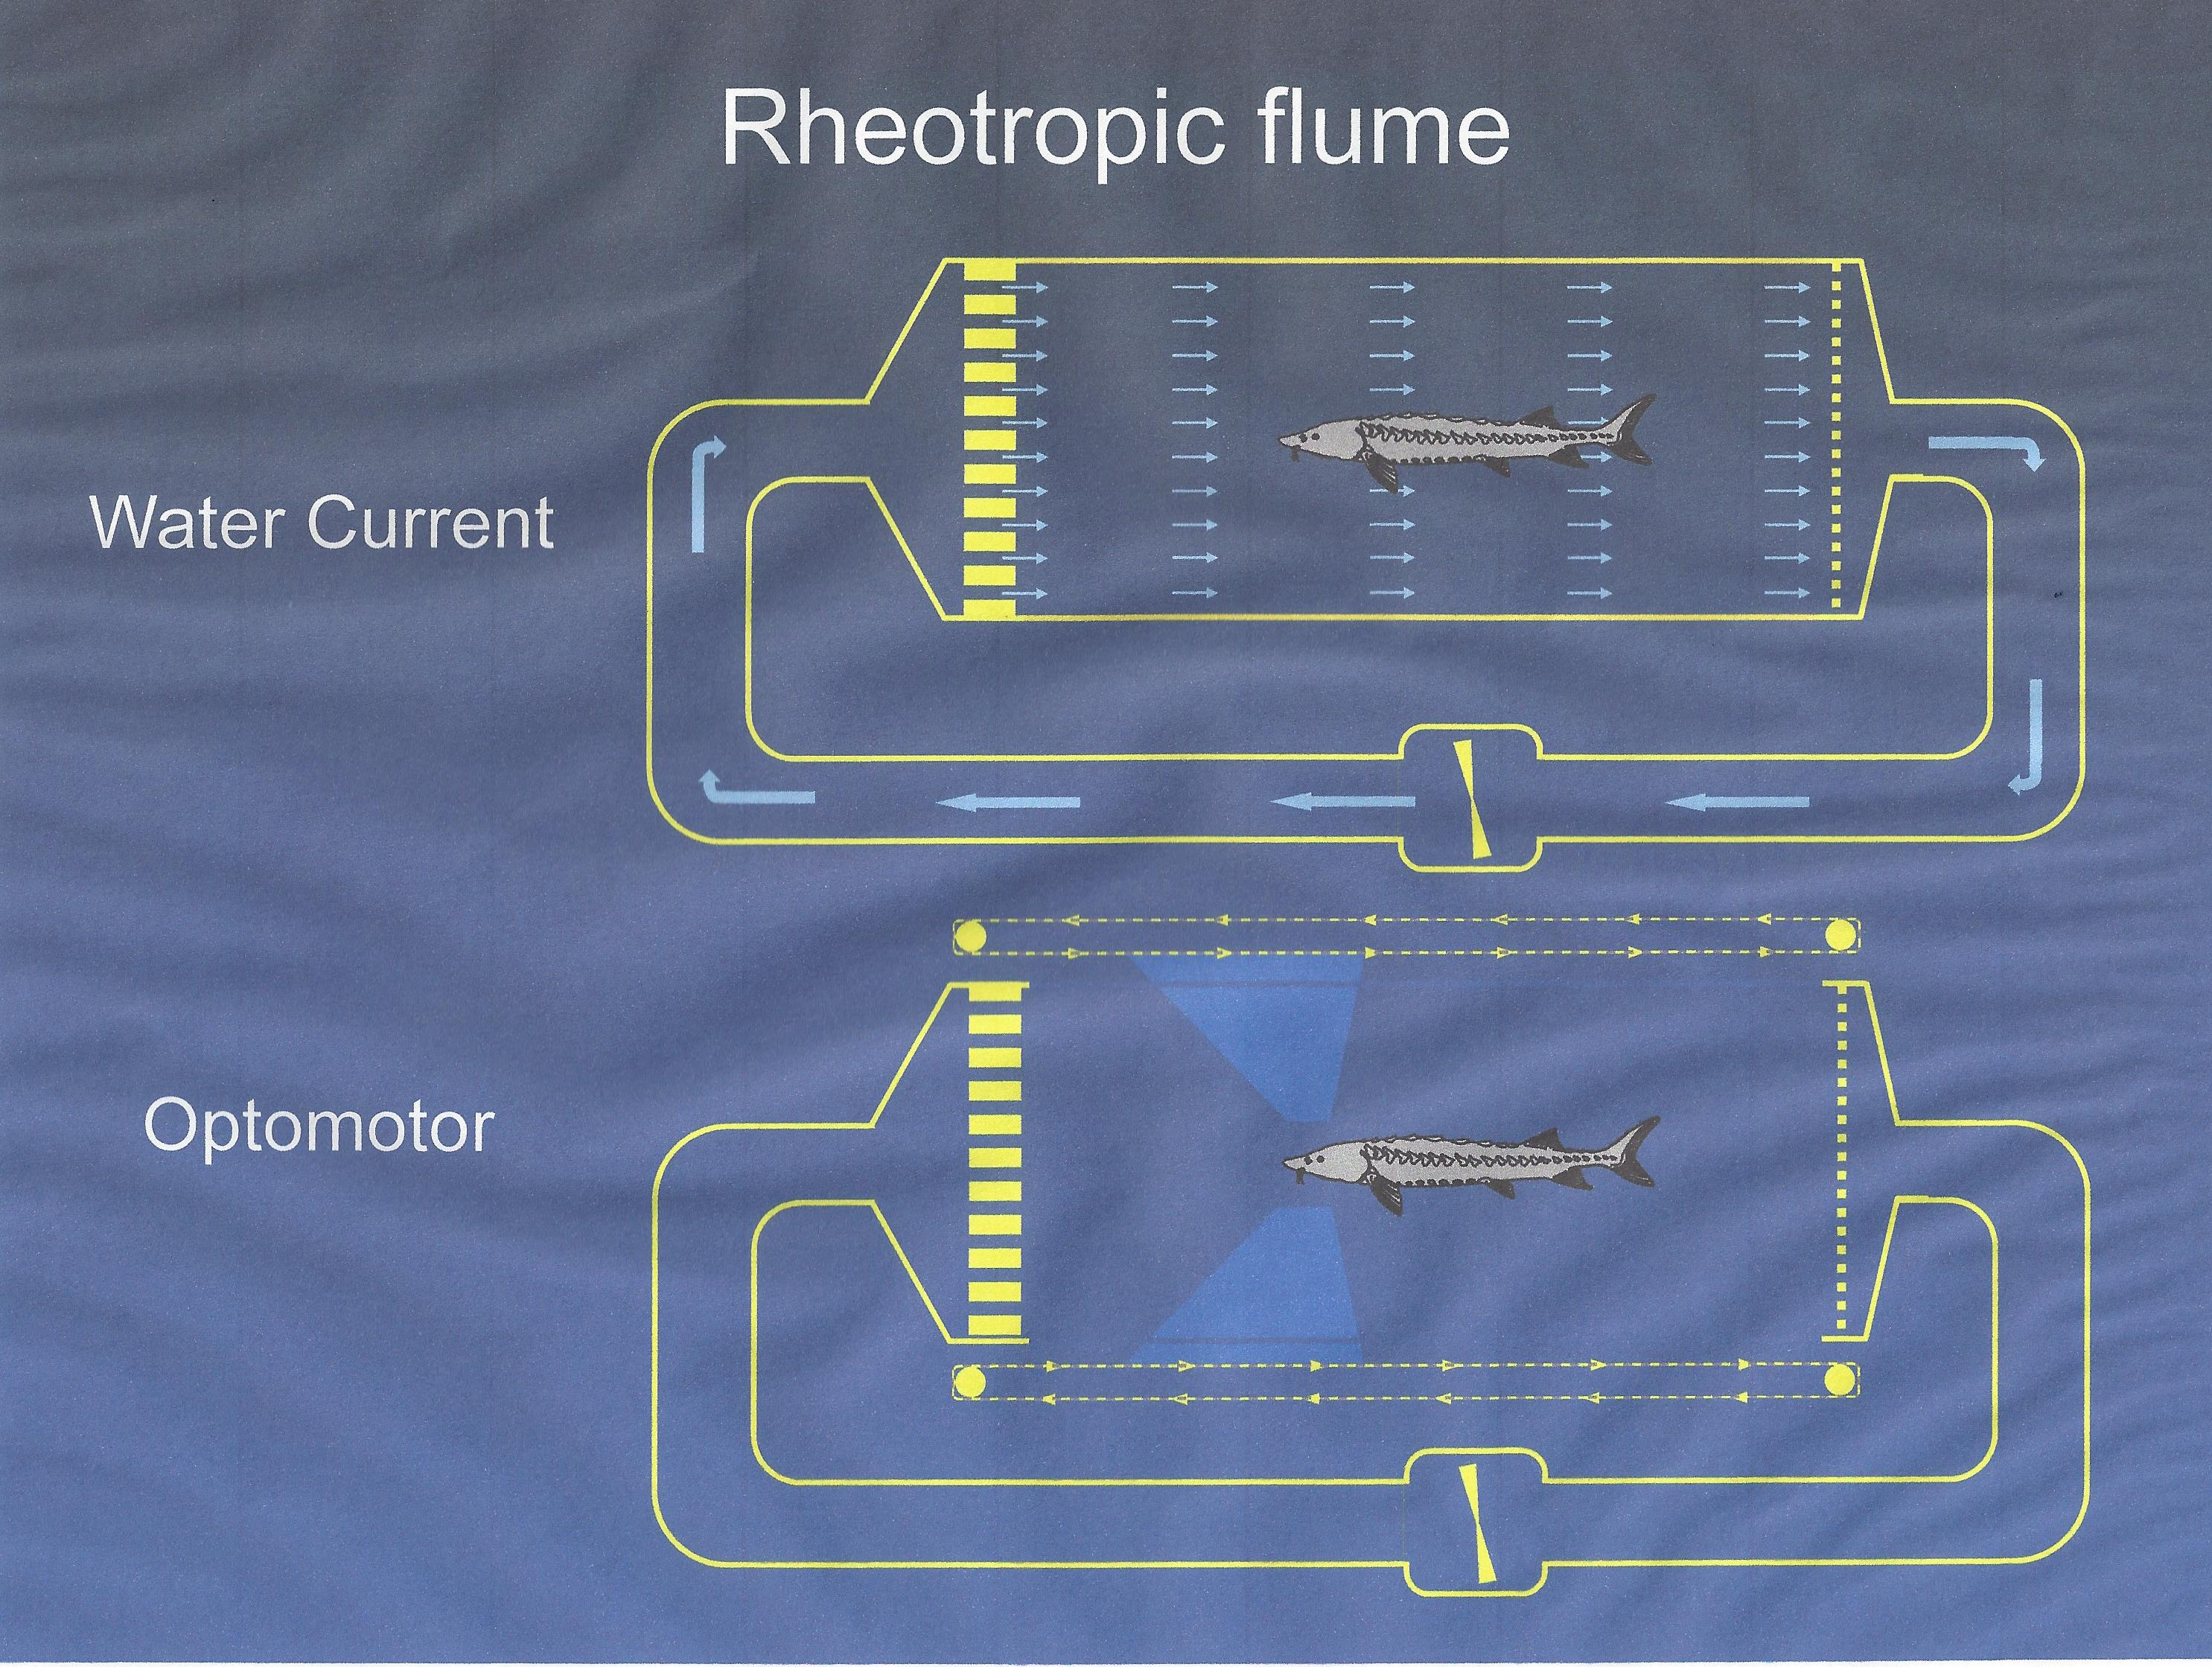

Figure 1

Figure 2

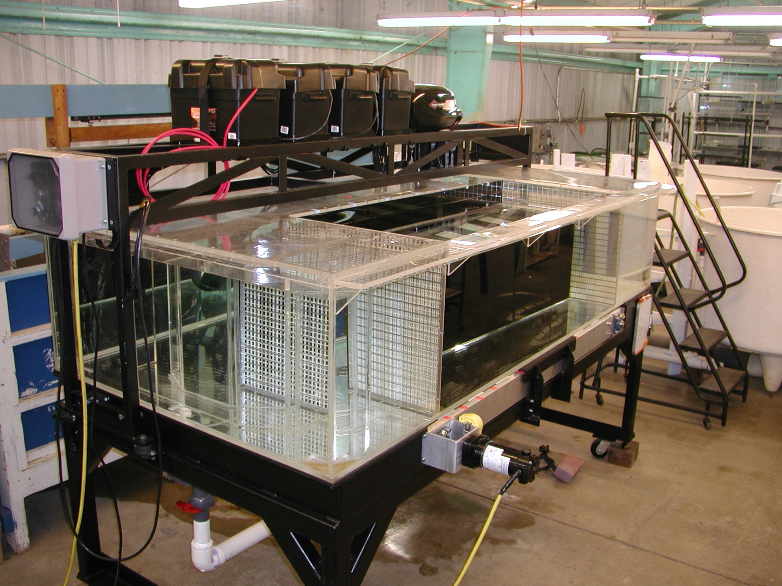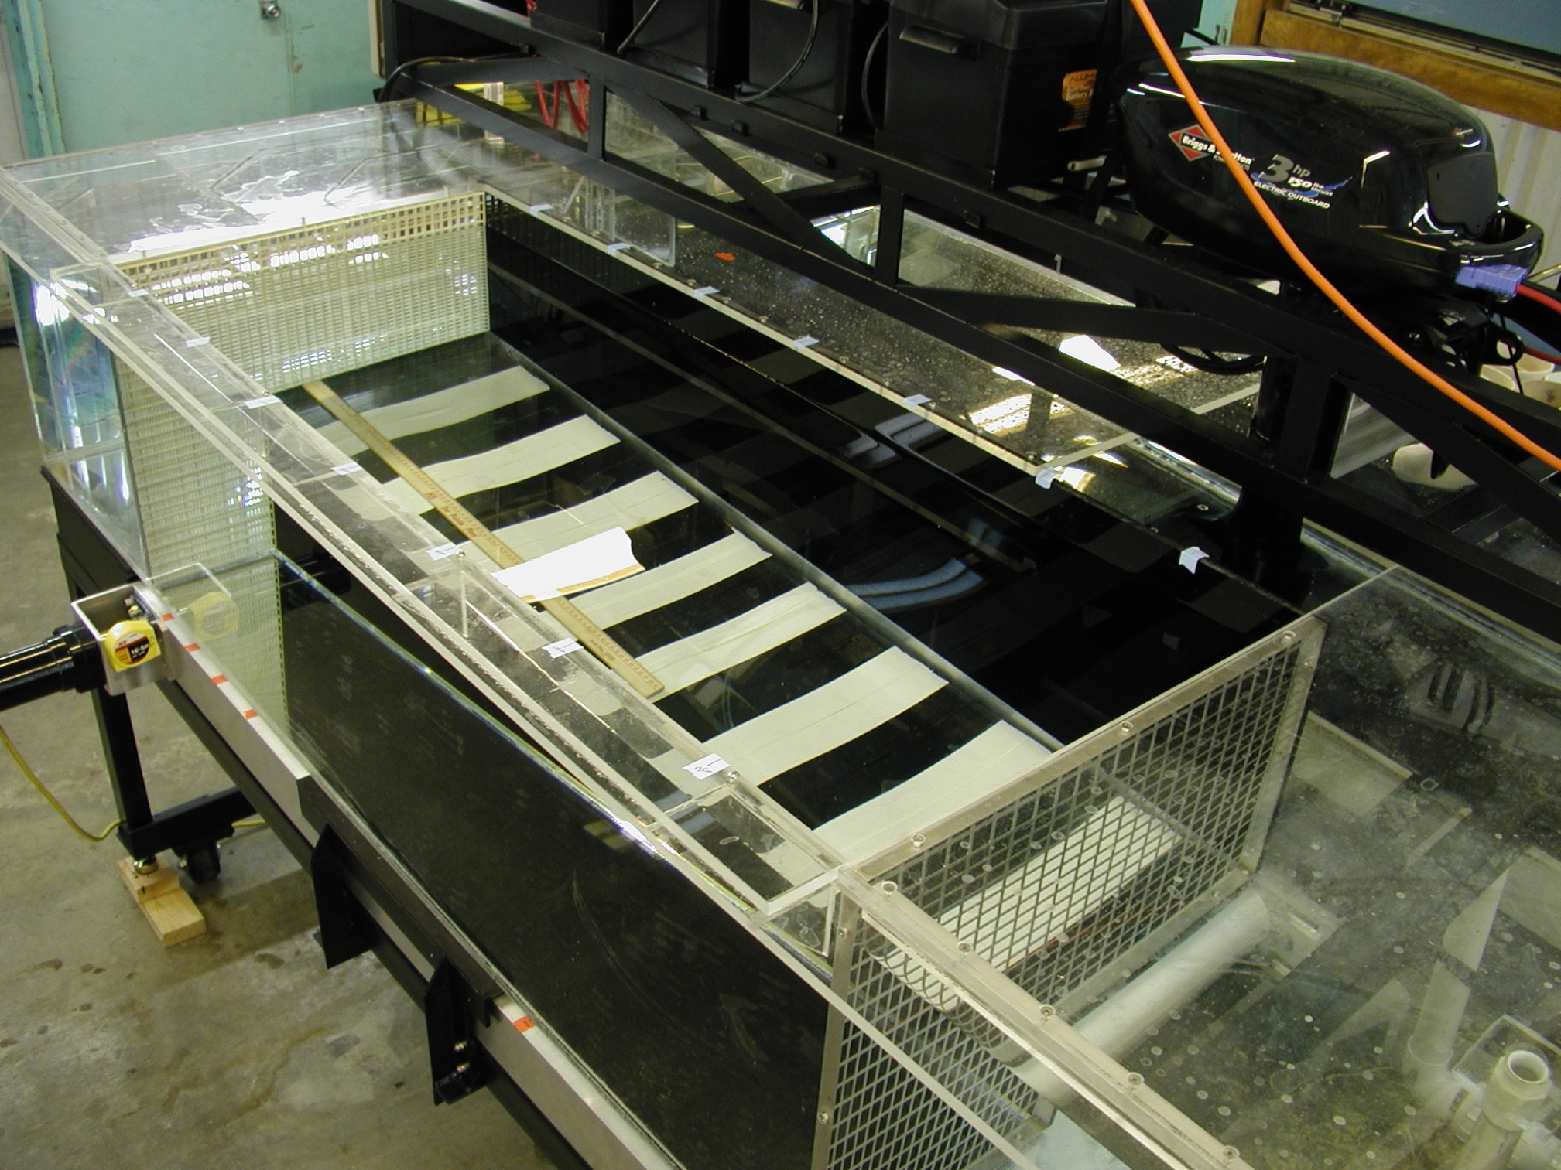

a

b

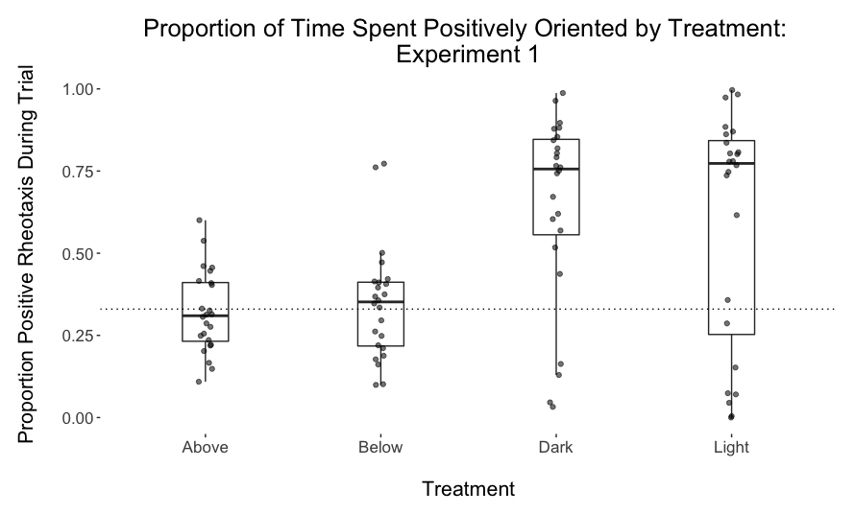

Figure 3

Figure 4

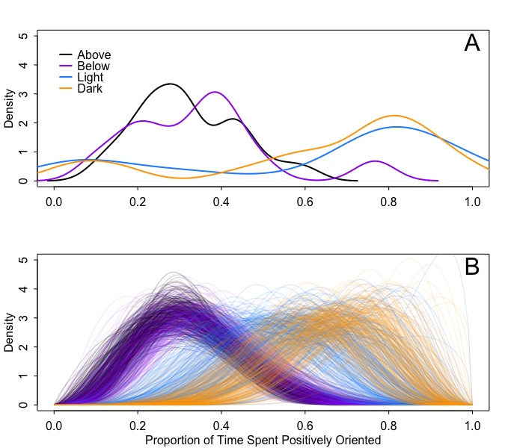

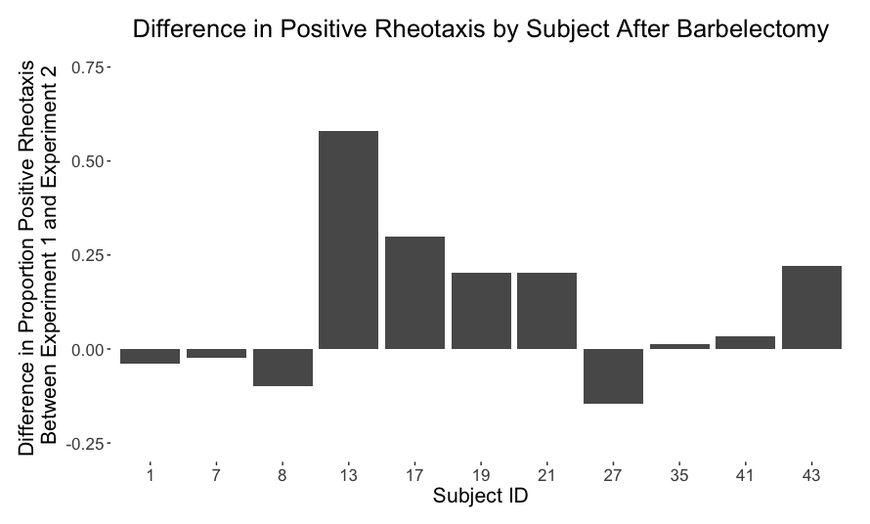Figure 5

Figure 5